EUR-Greece-Archaic-5th Cent BCE-Standing Woman

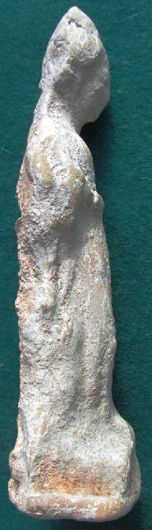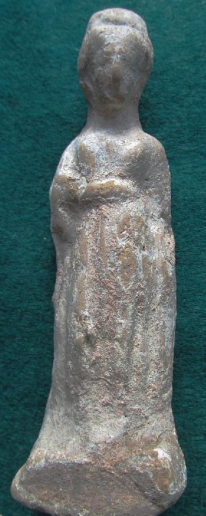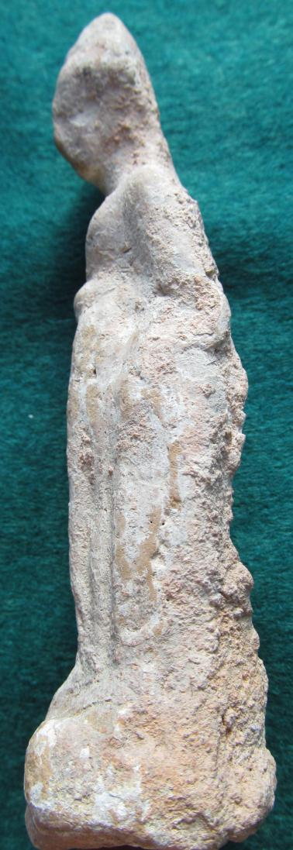

Greek Attic Terracotta, Standing Woman, with Himation, Chiton, Late Archaic, early 5th cent. BCE